Project number: 11
Project for Software Engineering Course

Money Map

 | Student Id | Student Name | Section | No.
1 | 0232410 | Yasmeena Abdel Kareem Alfauri | 3 | 20
2 | 0233493 | Ma’moun Hussam Yosef | 3 | 22
3 | 0234684 | Saja mohammad Owimer | 3 | 23
4 | 2220561 | Mona Ahmad Kreashan | 5 | 36

Supervised by: Prof. Amjad Hudaib
First Semester 2025/2026

Table of Contents
Money Map Summary 1
1.0 Introduction 1
1.1 Project Overview 1
1.1.1 The Purpose of the Project 1
Project Motivations 1
1.2 Objectives & Constraints 1
1.2.1 The Scope of the Work & Project Deliverables 1
1.3 Similar Projects 1
2.0 Feasibility Study 1
2.1 Technical Feasibility 1
2.2 Operational feasibility 1
2.3 Economic Feasibility 1
2.3.1 The needed Hardware and Software 1
2.3.2 Development Cost 1
2.4 schedule feasibility 1
2.4.1 schedule 1
2.4.2 pert diagram : 1
2.4.3 Gantt chart : 1
2.5 Legal Feasibility 1
3.0 System Specification 1
3.1 Stakeholders 1
3.2 Data Gathering Techniques 1
3.3 Functional Requirements 1
3.4 Non-Functional Requirements 1
3.5 Domain Requirements 1
3.6 Requirements Analysis and the Design 1
3.7 Architecture Design 1
4.0 System Design 1
4.1 Class Diagram 1
4.2 Use-Case Diagrams 1
4.3 Use-Case Diagrams 1

Money Map Summary

The Expense Budget Planner project aims to create a simple and smart platform that helps people manage their money more easily. It allows users to track their daily expenses, see clear charts of where their money goes, predict upcoming monthly costs, and get helpful saving tips based on their spending habits. The main goal is to help users build better financial habits and reach long-term stability.

The project will include setting goals, doing research, designing an easy-to-use interface, and developing systems that can analyze spending patterns and predict future expenses. These features will work together to give users clear insights, personalized advice, and practical tools to improve their budgeting.

Main results of the project will include an expense tracking dashboard, savings suggestion system, prediction tool, and user-friendly design. The development process will follow clear steps to make sure the platform works smoothly and meets user needs.

The project will need a team with skills in web development, data analysis, finance, and design. It will also use software tools like data visualization systems, secure databases, and financial APIs to track and analyze spending.

Important points to focus on are keeping user data safe, ensuring accuracy of predictions, and making the system easy for everyone to use.

In short, the Expense Budget Planner will help people take control of their finances by offering simple visuals, smart predictions, and practical saving suggestions to support a more stable and confident financial future.

1.0 Introduction
A Web based application designed for anyone who wants manage their budgets efficiently by visualizing spending patterns, providing personalized saving suggestions to improve overall financial stability and clear advice to save more money based on their daily spending habits.

1.1 Project Overview

1.1.1 The Purpose of the Project

This planner aims to simplify budgeting by offering real-time insights, categorized expense tracking, and goal-based savings recommendations. Whether for students, families, or professionals, the tool supports better financial decision-making, helping users achieve financial freedom through smarter budgeting and consistent saving habits.

Project Motivations

- Encourages mindful spending and better budgeting habits.

- Promotes financial awareness and understanding of income versus expenses.

- Supports disciplined saving through personalized recommendations.

- Helps identify gaps between current finances and desired goals.

1.2 Objectives & Constraints

Objectives:

- Helping users achieve their financial freedom and stability goals through personalized budget management and savings roadmaps.

- Enhancing the financial decision-making process by offering tailored spending predictions and expense visualizations based on each user's unique income and transaction history.

- Help people achieve their financial wellness goals and to have a balanced life for their spending, saving, and managing debt while maintaining economic comfort.

- To provide users with the knowledge and tools they need to make smarter spending choices, manage their cash flow effectively, and reduce the rate of financial stress or unnecessary debt.

Some of the Constraints:

- Only registered users can access the application to view their personalized expense reports and saving suggestions, which helps keep financial information private and secure.

- The system fully depends on the data entered by the user. If the information is missing or inaccurate, the predictions and reports might not reflect the real financial situation.

- All user data needs regular maintenance and updates to improve accuracy, preventing unauthorized access or data leaks, and ensuring the privacy of each user.

- The website needs regular maintenance and updates to improve accuracy, fix technical problems, and make sure users have smooth and reliable experience.

1.2.1 The Scope of the Work & Project Deliverables
Deliverables (Business Requirements) – Money Map
- User-Friendly Interface:
Money Map must be simple and easy to use for everyone, even if they aren’t tech-savvy.
- Responsive Design:
The app should work smoothly on desktop, tablet, and mobile devices.
- Expense Tracking & Budgeting:
Users must be able to log expenses, categorize spending, and track budgets easily in real-time.
- Predictions & Savings Suggestions:
Money Map should predict monthly expenses and give personalized savings tips based on user habits.
- Visual Analytics:
Users should see interactive charts and graphs to quickly understand where their money is going.

1.3 Similar Projects

There are some software programs that help lawyers manage their tasks and schedules. Here are some examples:

- Goodbudget : Is like giving each spending category its own little safe. You decide how much goes in each safe ahead of time. Then when you spend, you take from the right safe and you always know how much is left. It keeps things visible, simple, and shared especially helpful if you’re budgeting together

- Lunch Money : Is an app that shows all your finances in one place. It helps you track your spending, budget, and savings easily without doing much manual work. It’s clean, modern, and safe because it doesn’t use ads or sell your data.

- YNAB : Is a budgeting website that helps you plan where your money goes before you spend it. It teaches you to set priorities, save for future expenses, and stay flexible when things change. In short, it helps you control your money instead of spending without a plan.

- Wallet : This app helps you track your expenses and manage your budget easily. It’s like having a smart notebook for your money on your phone or computer.

2.0 Feasibility Study

The feasibility study assesses the practicality of the mental health website project, analyzing technical, economic, legal, operational, and schedule aspects to determine the project's potential for success.

2.1 Technical Feasibility

The technical feasibility focuses on the technological resources required for the project, including hardware, software, and technical expertise.

- Team Expertise: Requires web developers to build the app, designers to make it easy to use and look nice, and data people who understand money and budgets so the app can give smart advice.

- Features: The website can do things like track your spending, predict next month’s expenses, suggest ways to save, and show charts that make it easy to understand where your money goes. You can also connect it to your bank or other money apps if needed.

- Challenges: The tricky parts are keeping your financial info safe, making sure the predictions are accurate, and building it so it works smoothly for lots of users at the same time.

- Technology Stack :

- UI design:

- Frontend: HTML, CSS, JavaScript

- Backend: FLASK

- Database: AWS RDS

Hosting: Google Cloud. All the needed technologies are free, and the skills to use them are within our team's reach.

2.2 Operational feasibility
The main goal of Money Map is to make managing personal finances easy and efficient.

- Target Audience: The website is for anyone who wants to manage their money better — students, professionals, families, or anyone trying to save and plan their expenses.

- User Experience: The website should be easy to use, with clear navigation, interactive charts, and personalized suggestions for saving and budgeting so users can quickly see where their money is going.

- Maintenance: The team should update the app regularly with improved spending predictions, updated financial tips, and new features that help users track and save money more effectively.

- Support: It’s important to have customer support, like chat help, email, or FAQs, so users can get help if they have questions or problems with their budget tracking.

2.3 Economic Feasibility

2.3.1 The needed Hardware and Software

 | Description | Quantity | Unit price (USD) | Total price | Note
HD1 | Laptop | 4 | 500 | 2000 | For software development and testing the user interface
HD2 | PC | 1 | 800 | 800 | For software development and testing the user interface
HD3 / CS1 | Google Cloud | 1 | 50 | 50 | For deploying and hosting the web application
HD4 / CS2 | AWS RDS (Database Service) | 1 | 50 | 50 | For hosting and managing the web application’s database
SW1 | FLASK (Backend) | - | - | - | For Backend operations
SW2 | Web Interface Development (HTML, CSS, JavaScript) | - | - | - | For building the Frontend interface of the website
SW3 | AI Integrations | - | 50 | 50 | For AI automations and suggestions
SW4 | Conversational AI Agent | - | 50 | 50 | For handling user queries and providing automated intelligent responses and analysis.
Total |  |  |  | 3000
Table1.The needed Hardware and Software

2.3.2 Development Cost

Items | Description | Cost
Application Hosting | Google Cloud
DB Hosting | (AWS RDS) For hosting and managing the web application’s database. | 0.019 USD/hour.
LLM | Gemini-2.5-Flash | For 1M token  Input(0.30$).  Output(2.50$).
Table2 Development Cost

2.4 schedule feasibility

- Time Estimates:

- Requirements gathering:

- Design and development:

- Testing and deployment:

- Challenges:

- Project Management:

2.4.1 schedule

Tasks | Description | Duration Time | Dependency | Responsible Partner/s, Staff | Resources
Task 1 | use cases | 2 days |  | Yasmeena
Task 2 | Feasibility study | 6 days |  | Ma’moun
Task 3 | Questionnaire preparation | 4 days | None | Yasmeena&Saja | Google forms
Task 4 | Requirements | 12 days |  | Yasmeena&Mona
Task 5 | Arch design | 2 days |  | Mona | Power point
Task 6 | Data gathering &stakeholders |  |  |  | Google search + websites
Task 7 | class diagram |  |  | Ma’moun | Lucid Chart
Task 8 | System design |  |  | Ma’moun | Similar application called Wallet
Task 9 | Implementation | 6 days |  | Ma’moun&Saja
Task 10 | Sequence Diagrams
Table 3.Schedule

2.4.2 pert diagram :

2.4.3 Gantt chart :

2.5 Legal Feasibility

The Expense Budget Planner must follow data protection laws since it deals with sensitive financial information. The app should get user consent before collecting personal or banking data. Any third-party services (like bank APIs) must also comply with privacy regulations to keep users’ financial info safe.

3.0 System Specification

3.1 Stakeholders
St ID | Stakeholder | Notes
St1 | users | Who will use the system to find their needs
St2 | Product Manager | Who will manage timeline, budget, and team coordination to meet project goals.
St3 | Developers | The team that make continuous development for code and the app.
St4 | System Administrator | The person who takes care of the servers, security, and keeps everything working smoothly.
Table 4. Stakeholders

3.2 Data Gathering Techniques

- Interviews: Conduct one-on-one interviews with potential users of the MONEY MAP, such as students, professionals, or families. Ask questions to understand their spending habits, budgeting challenges, and financial goals. Also gather input from financial advisors or experts to ensure the app’s features align with effective budgeting practices.

- Surveys/ Questionnaires: Create surveys for potential Money Map users (students, professionals, families) to learn about their spending habits, budgeting challenges, savings goals, and desired features. This helps identify trends and priorities so Money Map can offer the best experience.

- Document Analysis: Reviewing bills, financial statements, and expense lists. To identify what type of data the system must support.

++++++++++++with pictures

3.3 Functional Requirements

Functional Requirement: A specific feature or function that a system must perform.

- For priority, 5 means highest and 1 means lowest priority.

- Functional requirements will be divided into 3 Increments.

- Increments delivery will start from increments 1 to 3.

No. | Functional Requirements | Description | Increment | Stakeholders | Priority | Notes
FR1 | User Registration | Allow users to create new account . | 1 | Users  Developers | Hight | Basic function to start using the system.
FR2 | User Login | Users can log in securely to access their data. | 1 | Users  Developers | Hight | Must include authentication and validation.
FR3 |  | Help users reset forgotten password . | 1 | Users  Developers | Medium | Use email verification for security.
  Password recovery
FR4 | User-profile management | Let users edit personal information and preferences. | 1 | Users  Developers | Medium | Helps manage account details easily.
FR5 | Edit/delete expense | Allow users to modify or remove expense records. | 2 | Users | Medium | Needed to maintain accurate data.
FR6 | Add / Remove Accounts | Users can input income sources and amounts. | 2 | Users | Hight | Allows users to manage different income sources easily and keeps their financial data accurate.
FR7 | Search & filter Transactions | Users can Add, Delete or Edit an Account. | 2 | Users | Hight | Improve data accessibility and navigation.
FR8 | Add expense | Record expenses with amount, data and category. | 2 | Users | Hight | Core feature; should be simple and fast to use.
FR9 | Dashboard overview | Display summary of income, expenses and saving. | 3 | Users | Hight | Main screen for financial overview.
FR10 | Data visualization | Show simple charts of spending and income. | 3 | Users  Developers | Medium | Improves user understanding visually.
FR11 | Spending alerts | Notify users when approaching or exceeding budget. | 3 | Users | Medium | Helps users stay within limits.
FR12 | Darl/light mode option | Allow users to switch between light and dark modes. | 3 | Users  Developers | Low | Enhances visual comfort and personalization.
FR13 | Saving suggestions | Suggest ways to save based on user spending. | 3 | Users | Medium | Encourages better financial habits.
FR14 | Generate reports | Export financial summaries by Ai agent. | 3 | Users | Medium | Useful for record keeping.
FR15 | Ai agent assistant | An Ai-based agent that analyzes, spending , give recommendations and advice. | 3 | Users  Developers | Hight | Offers smart insights and saving suggestions.
FR16 | Multi-currency support | Allow users to select their preferred currency. | 3 | Users  Developers | Low | Improves usability for international users.
FR17 | Expense categorization | Organize expenses into categories. | 3 | Users  Developers | Medium | Can be manual or automated later.
FR18 | Budget Goal Setting |  | 3 |  | High
  Allow users to set monthly or yearly saving goals and track their progress.
  Users, Developers
  Helps users plan and achieve financial targets.
FR19 |  |  | 3 |  | Medium
  Expense Receipt Upload
  Let users upload images of receipts, and the system extracts data automatically (optional OCR).
  Users, Developers
  Increases convenience by reducing manual entry.
FR20 |  |  | 3 |  | Low
  Currency Conversion
  Automatically convert expenses into a default currency using live exchange rates.
  Users, Developers
  Useful for international users or travelers.
FR21 |  |  | 3
  Data Backup and Restore
  Allow users to back up their financial data and restore it anytime.
  Users, Developers
  High
  Prevents data loss and ensures security.
FR22 |  |  | 3 | Users | Medium
  Monthly Financial Report
  Generate automatic monthly summary reports showing total income, expenses, and savings.
  Helps users review and reflect on their spending.
FR23 |  |  | 3 |  | High
  Spending Category Analysis
  Provide detailed insights into each expense category with charts and AI recommendations.
  Users, Developers
  Improves understanding of financial behavior.
FR24 |  |  | 3 | Users | Medium
  Search by Date Range
  Allow users to search transactions by specific date ranges.
  Enhances filtering and record-keeping.
FR25 |  |  | 3 | Users | Medium
  Goal Achievement Notifications
  Notify users when they reach a saving or spending goal.
  Encourages motivation and engagement.
FR26 |  |  | 3 | Users | Medium
  Transaction Export
  Users can export all transactions to Excel or PDF files.
  Helps in offline record analysis.
FR27 |  |  | 3 |  | Low
  Language Support
  Allow users to switch between English and Arabic language.
  Users, Developers
  Makes the app accessible by change the language based on option in settings.
FR28 |  |  | 3 |  | High
  AI Fraud Detection
  Use AI to detect unusual spending behavior and alert the user.
  Users, Developers
  Enhances financial security.
FR29 |  |  | 3 | Users | High
  AI-Based Requirement
  Use an Ai agent automatically predict the correct category for each expense based on the text, vendor name, or spending pattern.
  Reduces user effort and improves accuracy by learning from past expenses.
FR30 |  |  | 3 | Users | Medium
  Custom Category Creation
  Allow users to create and name their own spending categories.
  Improves personalization.
FR31 |  |  | 3 |  | High | Increases data security and privacy.
  Secure Logout and Auto Timeout
  Automatically log users out after inactivity to protect privacy.
  Users, Developers
FR32 | AI-Driven Spending Insights & Categorization | An Ai agent that automatically categorizes expenses and generates smart spending insights. | 3 |  | High | Learns from user behavior over time, making predictions and insights more accurate.
  Users, Developers

3.4 Non-Functional Requirements

Non-Functional Requirement: A criterion that defines the quality or performance of the system, such as how fast the website should load or how secure it must be.

- For priority, 5 means highest and 1 means lowest priority.

Non-Functional Requirement | Description | Priority
1. Security | All users and financial data must be secured. | 5
2. Reliability | System uptime should be at least 99%. | 4
3. Usability | The interface must be simple and easy to use. | 5
4. Performance | The system should load main pages within 3 seconds. | 5
5. Privacy | User data must not be shard without permission. | 5
6. Maintainability | Code must be modular and easy to update. | 3
7. Accuracy | Financial calculations must be 100% correct. | 5
8. Backup & recovery | Data should be automatically backed up daily. | 4
Table 6. Non-Functional Requirement

3.5 Domain Requirements

DR-ID | Description
1
  The system must calculate total income, expenses, and remaining balance accurately.
2
  Every expense should be categorized (e.g., Food, Bills, Transportation(.
3
  The system should alert users when spending exceeds their set budget.
4
  The AI Agent should analyze user spending and suggest saving strategies.
5
  User financial data must remain private and secure.
Table 7. Domain Requirements

3.6 Requirements Analysis and the Design

G1: User & Access Management
- FR1: User Registration – Allow users to create a new account.
- FR2: User Login – Enable secure login to access personal data.
- FR3: Password Recovery – Support resetting a forgotten password.
- FR4: User-Profile Management – Edit personal information and preferences.
- FR27: Language Support – Switch between English and Arabic from settings.
- FR31: Secure Logout and Auto Timeout – Automatically log out inactive users to protect privacy.

G2: Accounts & Transaction Management
- FR5: Edit/Delete Expense – Modify or remove stored expense records.
- FR6: Add / Remove Accounts – Manage income sources and related accounts.
- FR7: Search & Filter Transactions – Search, filter and navigate transaction history.
- FR8: Add Expense – Record a new expense with amount, date and category.
- FR17: Expense Categorization – Assign each expense to a specific category.
- FR19: Expense Receipt Upload – Upload receipt images; the system extracts data automatically.
- FR20: Currency Conversion – Convert expenses to a default currency when needed.
- FR24: Search by Date Range – Filter transactions for a specific period.
- FR30: Custom Category Creation – Allow users to define and name new spending categories.

G3: Budgeting, Goals and Notifications
- FR9: Dashboard Overview – Show a summary of income, expenses and savings.
- FR11: Spending Alerts – Notify users when they approach or exceed their budget.
- FR18: Budget Goal Setting – Define monthly or yearly saving goals and track progress.
- FR22: Monthly Financial Report – Automatically generate a monthly summary of income, expenses and savings.
- FR23: Spending Category Analysis – Provide detailed insights per category.
- FR25: Goal Achievement Notifications – Send notifications when a saving or spending goal is achieved.

G4: Analytics, AI and System Services
- FR10: Data Visualization – Display charts and graphs of spending and income.
- FR12: Dark/Light Mode Option – Switch between visual themes for better comfort.
- FR13: Saving Suggestions – Recommend saving tips based on spending patterns.
- FR14: Generate Reports – Export financial summaries using the AI agent.
- FR15: AI Agent Assistant – Analyze spending and give smart recommendations.
- FR21: Data Backup and Restore – Backup financial data and restore it when needed.
- FR26: Transaction Export – Export transactions to Excel or PDF files.
- FR28: AI Fraud Detection – Detect unusual spending behavior and alert the user.
- FR29: AI-Based Requirement – Predict the correct category for expenses automatically.
- FR32: AI-Driven Spending Insights & Categorization – Continuously learn from user behavior to improve insights and categorization

3.7 Architecture Design
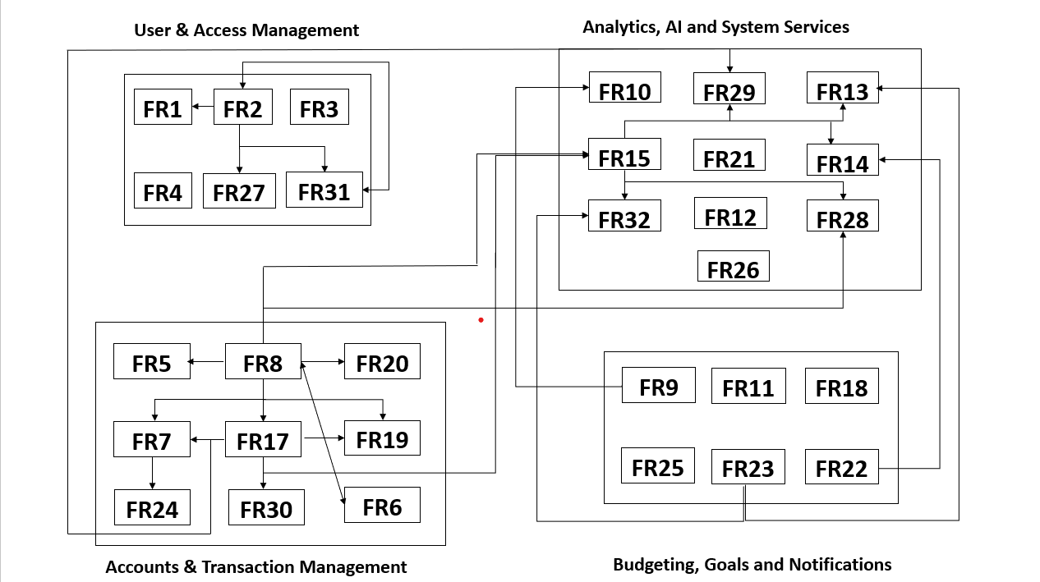

4.0 System Design

4.1 Class Diagram

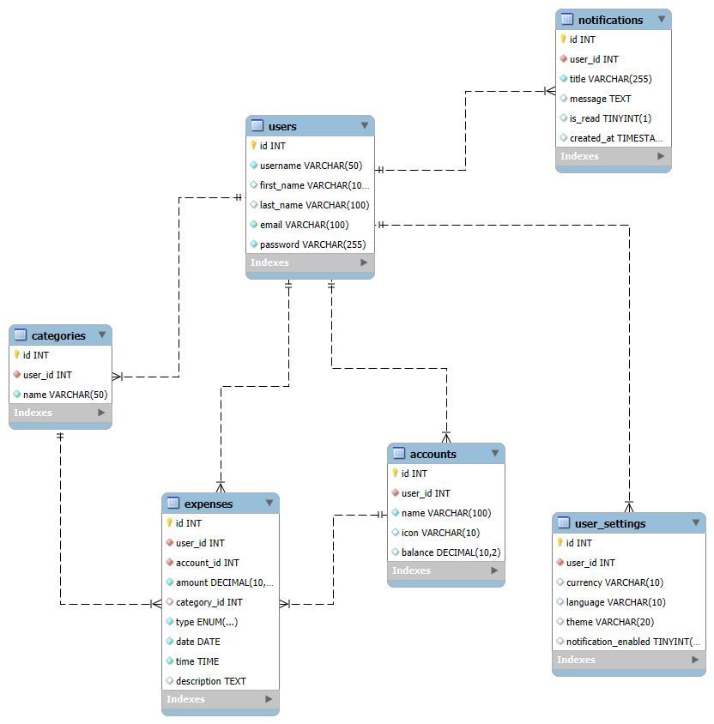

Use-Case Diagrams

USERS
FR1 — User Registration
FR2 — User Login
FR3 — Password Recovery
FR4 — User Profile Management
FR5 — Edit/Delete Expense
FR6 — Add/Remove Accounts
FR7 — Search & Filter Transactions
FR8 — Add Expense
FR9 — Dashboard Overview
FR10 — Data Visualization
FR11 — Spending Alerts
FR12 — Dark/Light Mode
FR13 — Saving Suggestions
FR14 — Generate Reports
FR15 — AI Agent Assistant
FR16 — Multi-Currency Support
FR17 — Expense Categorization
FR18 — Budget Goal Setting
FR19 — Expense Receipt Upload
FR20 — Currency Conversion
FR21 — Data Backup and Restore
FR22 — Monthly Financial Report
FR23 — Spending Category Analysis

FR24 — Search by Date Range
FR25 — Goal Achievement Notifications
FR26 — Transaction Export
FR27 — Language Support
FR28 — AI Fraud Detection
FR29 — AI-Based Categorization
FR30 — Custom Category Creation
FR31 — Secure Logout & Auto Timeout
FR32 — AI-Driven Spending Insights & Categorization

PRODUCT MANGER
FR9 — Dashboard Overview
FR10 — Data Visualization
FR13 — Saving Suggestions
FR14 — Generate Reports
FR15 — AI Agent Assistant
FR18 — Budget Goal Setting
FR22 — Monthly Financial Report
FR23 — Spending Category Analysis
FR25 — Goal Achievement Notifications
FR28 — AI Fraud Detection
FR32 — AI-Driven Spending Insights & Categorization

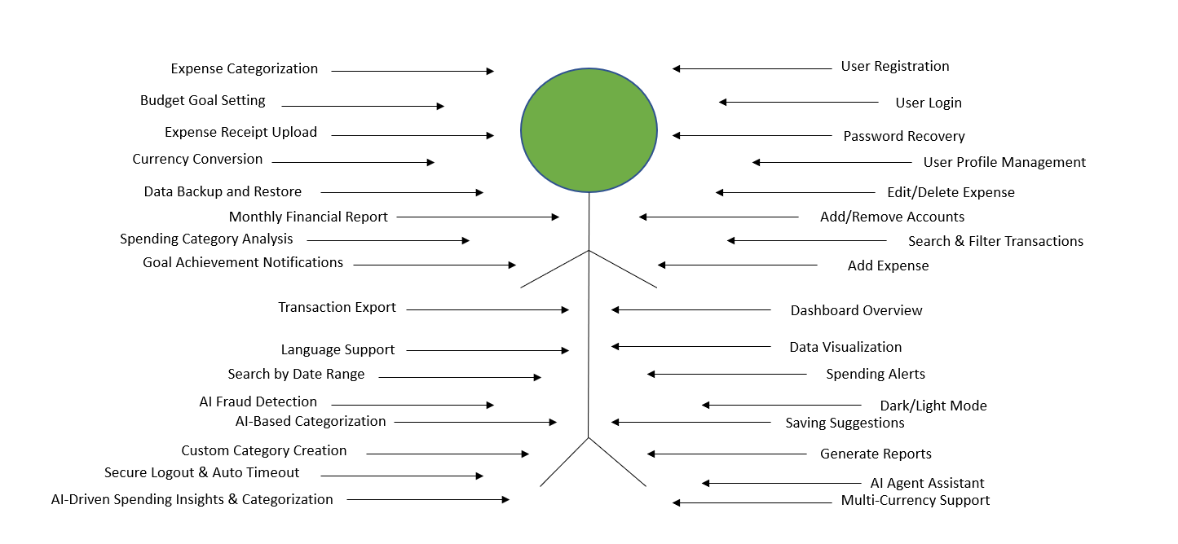

USERS
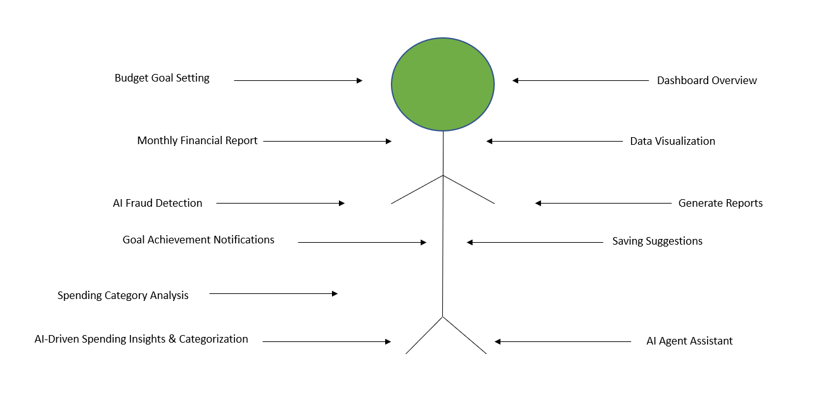

Product managers

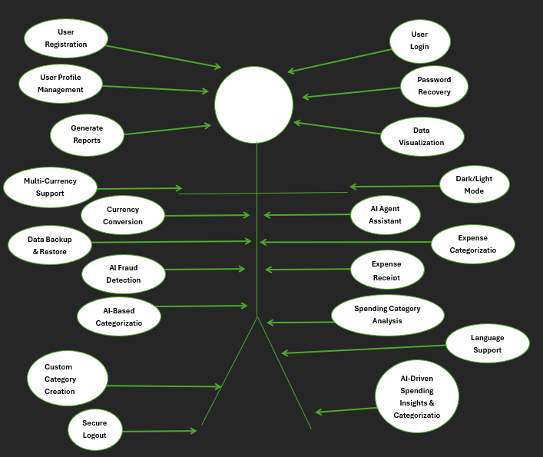

Developers

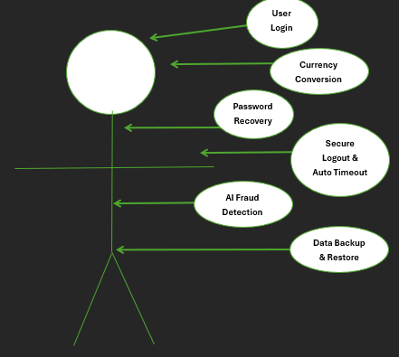
System Administrator

